TracxTMS User Guide

Tracx TMS is a Line of Business system built for the trucking Industry, it aims to encompass all the functionality needed by traditional trucking/delivery companies, as well as features designed to satisfy the needs of niche and specialist firms.
Line of business indicates that our software solution covers all the administrative divisions in your organization, except the role of accounting system. Tracx TMS, however, goes even further, as it includes deep integration with many of the most used accounting systems, to the point where Tracx Users can perform most data entry work for their accounting system through Tracx and needn’t even log onto their accounting software to perform most tasks (creating and settling invoices and purchases, driver/carrier reimbursement reconciliation, etc. etc.)

System Overview
The way TracxTMS is put together, the organization of the database, is detailed below (Fig1), and we’re going to use this to explain the fundamentals of how TracxTMS works, and how to get the best out of it. The Layout is divided into sections, and within it, layers. The area with the White background holds the entities that most users will be creating, editing and maybe deleting records from each day: the ‘Work’ tables. The Green Teal areas are the ‘Feeder’ tables; these hold the information that changes less frequently but provide the source information for the ‘Work’ tables. You can’t ‘Work’, or Quote a Load efficiently, without knowing about Locations, Customers, Drivers and Equipment; data needed from the ‘Feeder’ tables.
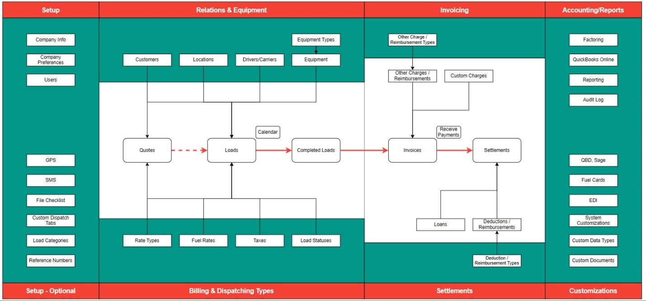
Figure 1 - TracxTMS System Layout

Feeder Tables
We’re going to go through the ‘Feeder’ sections first, and its these tables we’re going to help you populate as part of our on-boarding process; where we will look at your business and it’s process and merge these with your TracxTMS installation:
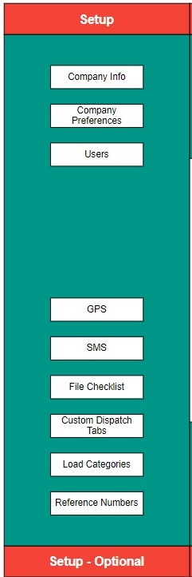 Figure 2 - Setup Section of TracxTMS System Layout
Setup: these tables hold the generic information needed to give context to the TMS system as a whole. Basic information on your company and how the system is configured to fit your business model, as well as a roster of the Users able to login to the system.
Optional Setup: these show some of the more specialist settings, integrations and categorization your firm might use to provide specific functionality in your TracxTMS instance; things most business will use, like GPS and SMS as well as categorizations and Reference numbers that are entirely customizable.
The first part of the post-Sales process is for us to determine, with you, the best way to set up Tracx to suit your businesses financial and logistical models while retaining our vitally important ease of use. Don’t worry, we’re going to walk you through the mountains of options in TracxTMS to get it tuned just how you want it.
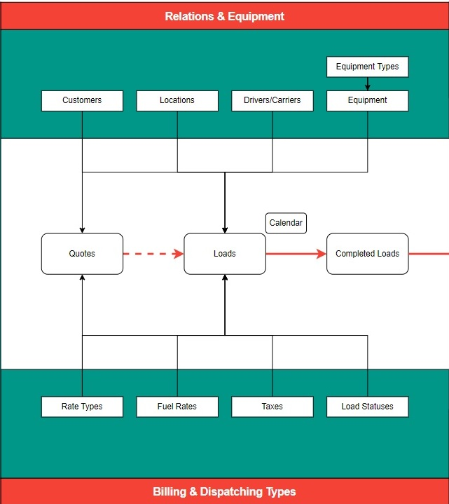 Figure 3: Main Section of TracxTMS System Layout

Relations & Equipment: this section holds the key ‘feeder’ tables, the data on your organization’s Customers, assets and people; this information is vital to your operations and it’s the combination of these elements that make a Load (we need equipment, driven by a driver/carrier, to go from one location to another on behalf of a customer). This is information you already have in your current system, or perhaps in a collection of Spreadsheets or Documents within your organization. The sooner we get these into TracxTMS, the quicker it will feel like it’s your system!
Billing and Dispatching Types: These feeder tables enable more detail to aid work in the Load module, information on Taxes, Billing & Fuel Surcharge Rates as well as the ‘Statuses’ your company uses to determine how far in the process your Load is, from the Quoting stage right through to the Bill for that Load being paid for by your customer. We’re going to help work through these options as part of our customer on-boarding process and you’ll find these elements don’t change very often once you are set up.
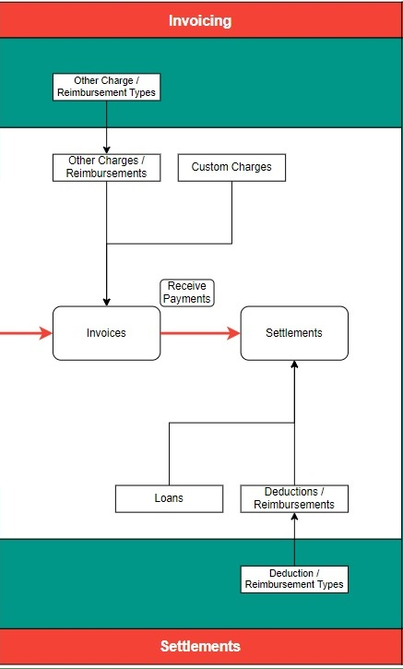 Figure 4: Invoicing Section from TracxTMS System Layout

Invoicing and Settlements: We realize that while doing business there maybe additional charges, costs and reimbursements that needs to be accounted for; this is where data on these are held, so that they can be used when needed.
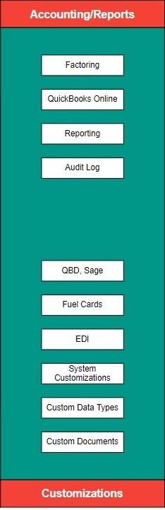 Figure 5: Reports Section of TracxTMS System Layout

Accounting and Reports: as part of our integration with your accounting system, we retain connection information, customer credit information as well as a library of commonly requested reports and an Audit trail of everything done in the system (logins and -outs, data edits and deletions).
Customizations: These are where the information needed only by some TracxTMS clients is held. Information on EDI (Electronic Data Interchanges), Fuel Cards and other ancillary integrations and customizations are stored. We’ll help determine these needs in the Discovery and Implementation stages of Onboarding you as a customer for TracxTMS.

Work Tables
The white ‘Work’ tables are where the magic comes to life, and the better the ‘Feeder’ tables are populated, the more streamlined the process of ‘getting trucking’ will be.
The fundamental building block of TracxTMS is the concept of a ‘Load’: one or more pieces of Equipment (Trucks & Trailers) driven by a Driver (or a sub-contracted Carrier) from Location A to B (and maybe C, D & E) on behalf of Customer(s). While the exact Equipment and Driver can be organized closer to the Load starting its journey, the price can usually be determined from the Location and Customer information only. Loads can be created for immediate use, or set up as a Quote, to ensure that you and the customer are on the same page regards the fundamentals of the Load, its logistics, and of course, the Cost, before the Load details are finalized.
Loads have a dispatch process, either when confirmed as Quotes, or closer to the Leave time as determined by your own companies’ Operations process. Some firms don’t assign a driver until the day of the trip, others pre-determine this according to any number of factors. Either way you’ll have a list of Loads along with their Statuses (En-Route, Confirmed, Cancelled, etc), organized, sorted and colour coded to your specifications, making it easy to see if there are any holes your plans prior to the rubber hitting the road!
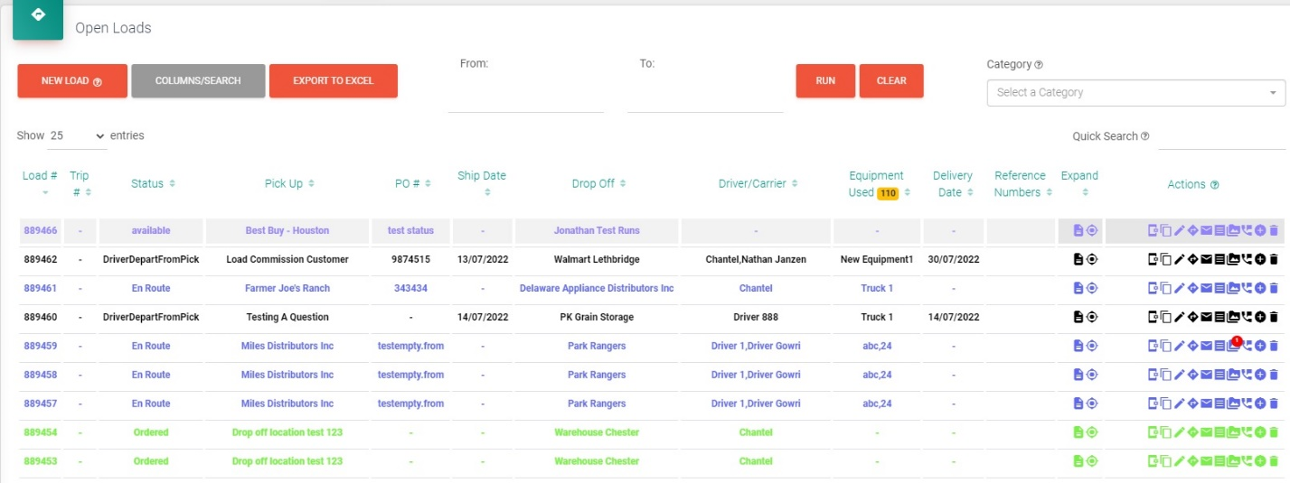
Figure 6: Open Loads List
TracxTMS also has a Calendar feature in order that you can ‘see’ your Loads in an easily digestible format, allowing dragging and dropping Drivers or Equipment to assign them to that Load.
When Loads are Completed, they are ready for Invoicing; and this process can be done and emailed directly from TracxTMS before being imported into your accounting system. Additional charges or credits can be added before or after the Invoice is sent and, as well, accepting Payments and Settling those Invoices can also be done in TracxTMS and those changes also imported into your accounting system.
In addition, TracxTMS can deal with reconciling Deductions and Reimbursements to your Drivers as well as any in-House Loans made to drivers. All this information is Synchronized with your Accounts Software. We’ll get into more details on these processes in their own section later._________ link____

TracxTMS Data Entry

Adding, editing, finding, sorting and deleting records in each of our tables (‘Feeder’ or ‘Work’) operates in the same manner. The screen for each of the entities follows a logical pattern, with common elements in the same places on each screen for ease of use. For the purposes of this we will use the Location table as an example to show you these regularly used features.

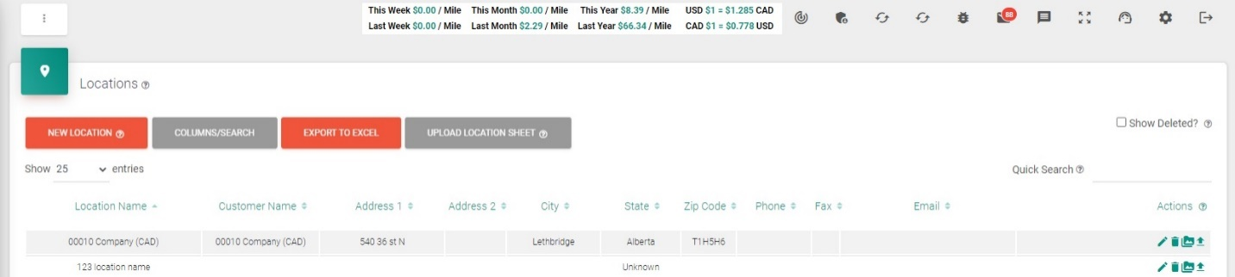
Figure 7: Location table in TracxTMS showing common elements
We’ll talk about these starting Top Left and working anti-clockwise.
Three Dots: These are used to toggle the Navigation area on the far left of your screen (black background, white writing) down to icons only, or back to icons and the Page name.
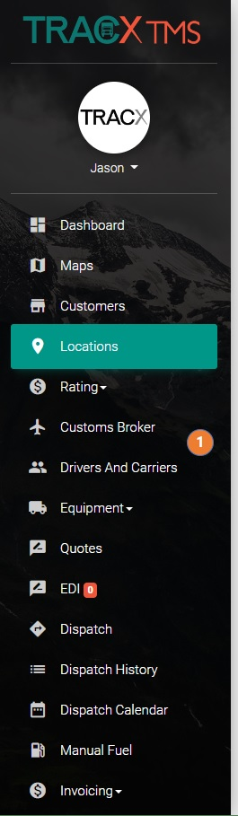 Figure 8: Full Navigation Bar Figure 9: Icon Only Navigation Bar

Below the three dots, next to the Table Icon (in our case a Map Pin) is the Table Name: ‘Locations’ in our case.
Beside the table name you’ll see a Question Mark inside a circle, what we call a ToolTip. You’ll find this icon throughout the TracxTMS system on text, buttons and many other on-screen elements. It works as a kind of on-line help system, if you click on the question mark it will give you a short description of what that element on-screen means, or what it does.
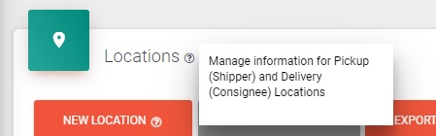 Figure 10: Tooltip example

Underneath our Table Icon and Name, you will find the primary action buttons you can use. Depending on the Table, you may have more or less buttons than you see here.
The first Button is the New Record, and as you can imagine this allows you to create a new item in which ever table you are in, in our case, we’d be creating a New Location record, either for a Pickup, a Delivery, or maybe a Billing or contact Location. We’ll go into entering New records when we look in depth at each table in the TracxTMS solution.
The second button is the Columns/Search button and as the name suggests, it performs two functions.
- Adding and Removing Columns in the list of records you see on-screen – by clicking on the Field Names (attributes) in the drop down that appears, you remove (white background, black text) or include (green Teal background, white text) those fields from the list (here I’ve removed the Phone, Fax and Email addresses from my list details.
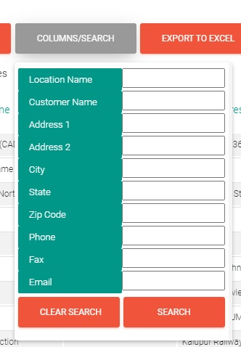 Figure 11: All columns 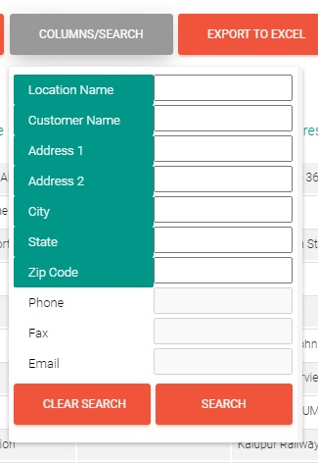 Figure 12:Columns removed
- Searching for particular records – when you want to restrict the records you see on screen to just those that match a particular criterion (eg a given City or State), enter that information in the appropriate white box and hit Search. (Here I’m about to Search for all Alberta Locations)
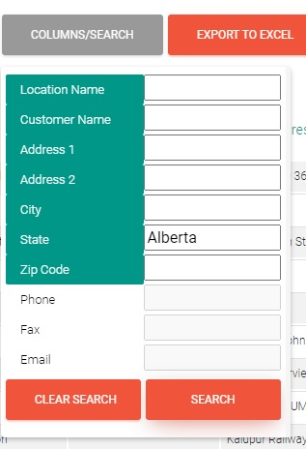
Figure 13: Searching

The Third button is the ‘Export to Excel’ button and this allows you to export the records you see onscreen (including those on later screens if there are a lot of records and you are only viewing so many entries at a time – we’ll cover this in a bit). If you have performed a Search (as we did in the last step) only the ‘Found’ records that match the criteria will be exported – ie just Alberta locations)
The fourth button will generally appear only on Feeder tables and is called ‘Upload Location Sheet’ (or whatever table you are in). This allows you to take information exported from a different system (say your CRM, accounts or assets management) as a CSV file, and import it directly into TraxTMS. This is usually done when we on-board new customers, to get as much of your information into TracxTMS as quickly as possible, so we can start ‘work’ on Quotes and Loads.
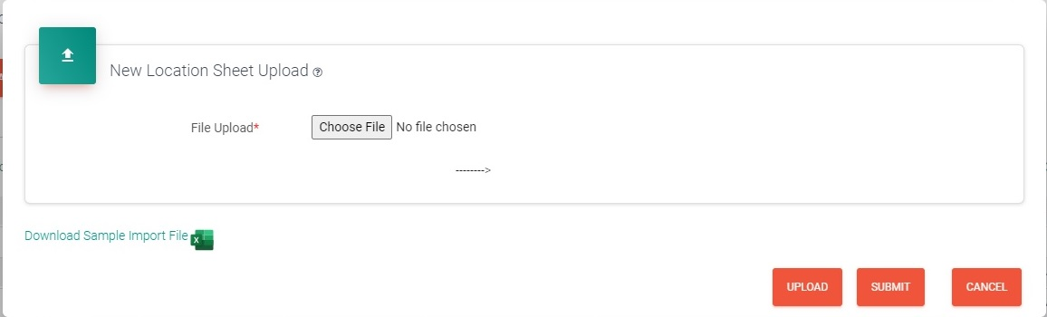
Figure 14: Location Upload screen

Each Upload option provides a sample CSV template, showing you which fields are required for each table and in which order data should be listed (so we don’t get phone numbers in Address fields and such)
Underneath the top left buttons is a Pagination Selector drop down, allowing you to change how many records are displayed in the list below on each page. The default is 25 entries, the other options are 10, 50, 100, 250 and All). ‘All’ allows you to force all the data into a single page (meaning you must keep scrolling to see later records) or it will only show the given number of records per page, meaning you must navigate from page to page to see the later records in your found set. (You set different defaults for Users your organization, instruction here ________link__________.
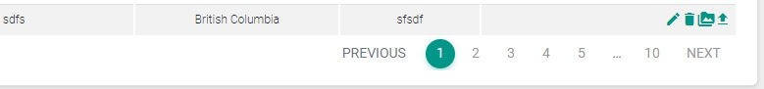
Figure 15: Pagination navigation

Underneath this is the data for the table we’re looking at (Fig 7 shows the Field Names: Location Name, Customer Name, Address1…..). Next to each field name you’ll see Sort arrows, which, if you click them, will toggle the group of records you are looking at into alphabetical or numeric order (or reverse order) according to that fields data. If you see both arrows next to a name, the list is not sorted by that attribute; if you see only one, that is the field the list is sorted by. It the arrow points up the list is sorted naturally (a..Z & 0…9); if the arrow points down, the list is sorted by that field name, but in reverse order. In Fig 6, the list is sorted by Location, in natural order.
The furthest right column in all the tables is the ‘Actions’ column and the icons you see there will be totally dependant on the table you are in and the various attributes of the data in that line. Hovering over the icons will give you a brief indication of what that button does (pencil=Edit record , trash can=Delete record, etc) We’ll go through the various actions when we look at individual tables.

Above the Actions column is a ‘Quick Search’ Feature, which allows you to enter any string of alphanumeric text and it will search, in real time all the fields in that table (even if the column the data is in is not displayed). It’s kind of like Google Search across the whole table and is often the most popular way of searching, as it can find data, even if, for instance, its in the wrong field (a zip/postal code in a Address field, for example.)
Lastly, above the Quick Search feature, you will find a check box marked ‘Show Deleted’, which, when checked, will include any previously deleted records that match the current Search (or all records, if that’s what is being currently shown. Fig 14 shows records found which contain ‘walmart.ca’ in any field, with two records which had previously been deleted marked with a red background.
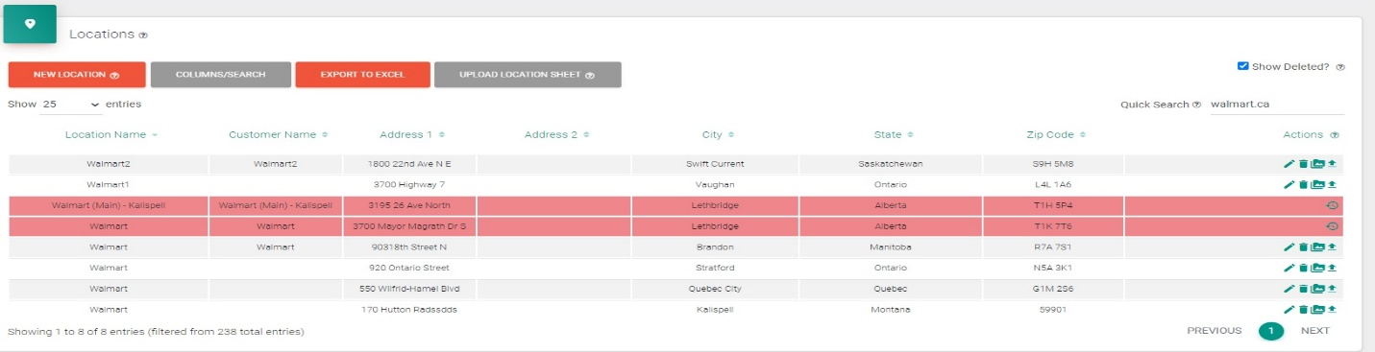
Figure 16: Show Deleted records example

Core Processes

The Main Navigation Area on the Left hand side of your TracxTMS Window show the Main sections you will use every day using the System. Let go through them now from top to bottom

Profile
The first thing you see is your Avatar and clicking it will Open up your System Profile, here you can change Your Avatar, job title, Phone and Fax number as well as define your email Signature. As TracxTMS automatically send emails on your behalf, you may want to set up a formal Signature, like that in your regular email application, so you can correctly follow your organizations external communications standards.
Above your Avatar, the words TracxTMS can also be clicked, doing this returns you to your Dashboard, regardless of where you were in the system; think of it as your ‘Home’ button.

Dashboard
This is your Home Screen, where you will arrive everyday after you have logged into TracxTMS. The Dashboard is a screen full of widgets, small graphs, lists and areas showing the key elements you need front and centre in order to perform your role in the organization. You can click on most elements, to drill-down into the details of the records the widgets refer to.
Generally determining what is on this screen is something we’ll help you decide when we’re onboarding you as a customer, but in case you need to change it afterwards ____________link________

Maps
This section uses Google Maps to build a Trip (multistep if necessary) so you can get ballpark ideas of time and mileage from any route you might be planning

Customers
Navigating to Customers in the main Nav area will take you to your list of customers and top right the ‘New Customer’ Button that we all hope to use lots every day!
The main tables we’re now getting into require quite a bit of information to work properly. Fields that are mandatory are marked with a little red asterix after their name (‘Customer Name*’ for example), any others are not, but please consider that the more fields you fill out now, the less chance you’ll need to fill them out later (like Tax Codes, FSC and billing rates) when you are trying to get that Load out the door.
The first subsection is General Information, the second, the details of your primary contacts at that customer and this section has a lot of functionality behind it. For each of the main contacts, you can choose to set up automated emails or SMS messaging for when their Loads reach a particular Status (En-Route, or Delivered, for example), when a piece of Equipment crosses a Geofence, or for sending Invoices. Filling in these features means you won’t have to do the work manually when the time comes; TracxTMS will know to do it automatically for you.
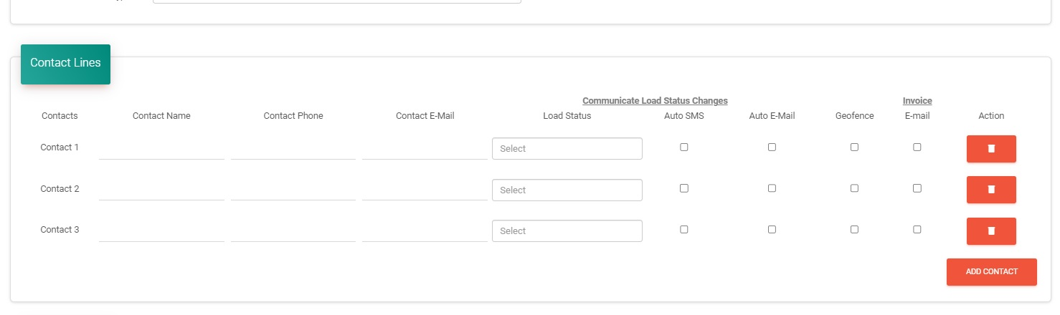
Figure 17: Customer Contacts and automated Email & SMS
After the Billing and Shipping Address sub-sections, you now have a section for that Customers clients, and their ability to enter their own loads, establish categories and download documentation relating to their loads. After that is ability to match this TracxTMS account with an account in your QuickBooks/or other accounting system. Lastly is the opportunity to record custom information for your cliuent, using Custom Fields Types (which we’ll explain later - here)

Locations
The next section is the all-important Location table. You can have as many Locations as you need and while the Name of the Location and its physical address are the only mandatory fields, by designating this address to a customer and denoting contacts will allow for more functionality later down the line. When entering a New Location, there’s also a Google Maps sections showing you where the location you have typed is and a field allowing you to enter in Notes (‘Like go round the back’ or ‘Beside WalMart’) to further explain to Drivers where they are to go.

Rating
Billing Rates is the sub-section where you detail the default rates charged to specific customers; you can add them quickly using the data entry line at the top. Some of the Rate Types are built in as standard, but you can add as many as you like using the Rate Types (which we’ll explain later – here), see the example below.
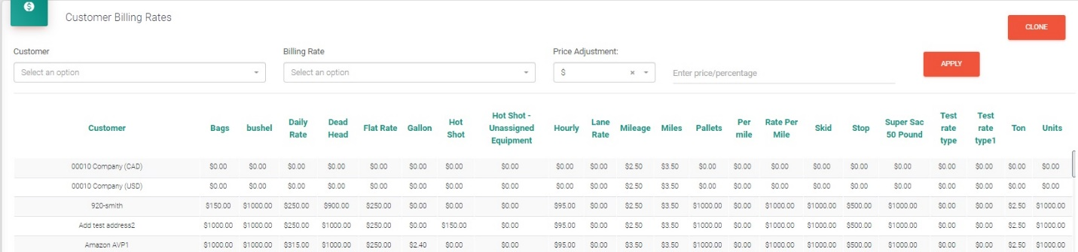
Figure 18: Customer Billing Rates
This allows you to build very specific billing mechanisms, so once you enter the type of goods being transported into your Load or Quote, TracxTMS will automatically choose the correct rate for you.
Enter in the details of the new rate you would like and hit Apply. You can also clone one customers rates onto another customer, or clone one rate for all customers to another rate.
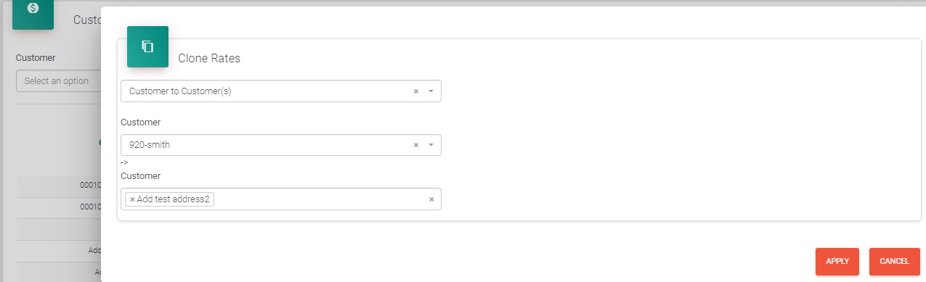
Figure 19: Cloning a set of rates from one customer to another
As well as adjusting Billing Rates, you can also adjust Fuel Surcharge (FSC) Rates and Accessorial Rates to cover ancillary charges you may have to make against particular customers. Detailing these out in advance ensures your company procedures are followed and the correct values charged.

Customs Brokers
Many trucking Companies are involved in International Routing, and therefore need details of Customs Brokers available to them in the system. Name, Phone, Fax and Email are the details needed for each one.

Drivers and Carriers
Another key Feeder database is that containing Drivers (employees, and individual subcontractors or owner operators) and Carriers (subcontracted trucking companies).
A bare minimum of details are mandatory, but as always, the more info you fill out the smoother you future use of TracxTMS will be. With Carriers, we’re not so interested in individual driver details, because Carrier is more of a placeholder for ‘we don’t know the actual individual who will be driving, our contractor will just send us whomever is available from their roster’
With our individual drivers however, we have a greater level of responsibility and it’s important to keep records of when their licence, passport and medical certifications expire. This is very important information and TracXTMS can block driver from being used if their information is not uptodate, saving the company potential liability issues.
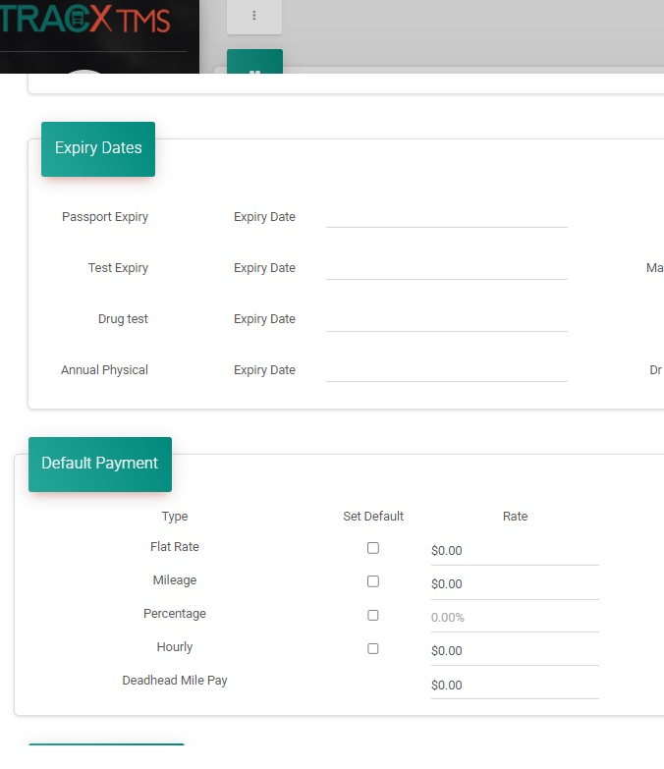
Figure 20: Driver Expiries and Reimbursement Rates
With all Drivers and Carriers we also keep details on the rates they are reimbursed so that TracxTMS can push this information to your accounting system automatically. You can create as many customer reimbursement rates as you like to compliment those included in the system (we’ll talk about this later – here.)

Equipment

TracxTMS Navigation

Main Navigation Area
Wherever you are in the TracxsTMS system, the left-hand side of your browser window is dedicated to the main Navigation Area. This means you can get to any of the primary sections in the System from anywhere using it. The Navigation Area has two modes: Icon & Text (Fig 8) and Icon only (Fig 9), the Icon only mode allowing more screen real estate for the rest of the system, at the cost of you having to remember which icon is which.
The Navigation options in the Main Area are dependant on the configuration/implementation of TracxTMS for your organization
NB: the main Navigation Area can have more items than fit on one page, so you may have to hover your mouse pointer over the area to reveal a bar that will let you scroll down (with your mouse wheel) to see the overflow navigation items.

Subsidiary Navigation Area
Top right on each page in the system in your browser window is the Subsidiary Navigation Area, which takes you to some of the lesser used areas of the system. You may not have all these options; it depends on your TracxTMS implementation/configuration. If you hover your mouse pointer over an icon, it will give you a tooltip explain what that button will do:
1 2 3 4 5 6 7 8 9 10 11
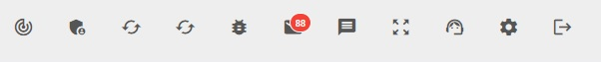
Figure 21: Subsidiary Navigation Area

1: Changelog list – provide a list of the recent bug fixes to the system
2: Admin features – Tracx Use Only?
3: Update QBD cache – Updates QuickBooks Desktop temporary (duplicate) storage area
4: Flush QB cache – Clears the QuickBooks (Online?) temporary storage area.
5: Report a bug/Send Feedback – this opens a new email to us at Tracx to let us know about a problem you’ve been having or a feature you’d like to see added.
6: Email Folder – this will take you to a list of the emails that users have sent from the system, depending on configuration there are usually two lists: Errors (email that didn’t go, for whatever reason) and History (emails that did successfully send). Red numbers on the icon indicate the number of errors emails you have on record.
7: SMS Folder – this will open a window showing you SMS send/receive history for your Drivers/Carriers
8: Broadcast SMS – This allows you to send a mass distribution SMS to all your Drivers/
Carriers. (You can add/remove individual drivers from the broadcast, but the default is to send to all)
9: Chat Folder – this will open a window showing you the ability to Live Chat with other users of your TracxTMS system (not drivers)
10: Settings – This opens a Popup Window with a large list of options, which we’ll detail in the next section (here).
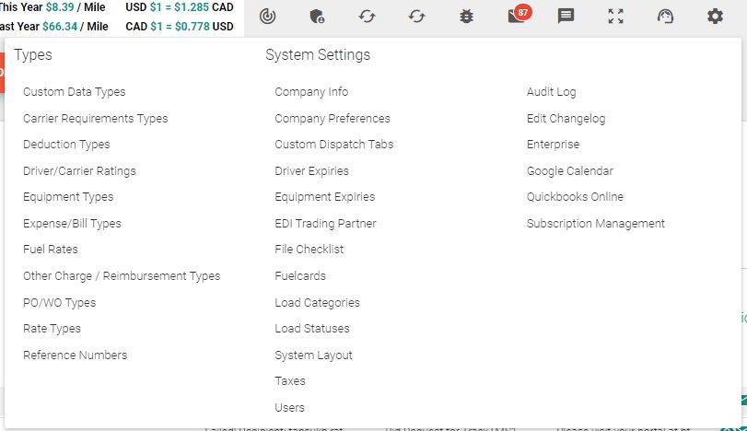
Figure 22: Advanced Settings

11: Logout – This takes you right out of TracxTMS, so that you will need your username and password to get back in

Advanced Settings

When you click on Settings from the Subsidiary Navigation Area, you get a large list of options, as detailed above in Fig 16. These control some of the more intricate customizations, integrations and configurations with TracxTMS.

Types
TracxTMS allows for a wide variety of custom ‘Types’, ways of categorizing similar types of data according to specific criteria.

Custom Data Types
These are extra fields that you have asked to be included in your TracxTMS installation in Specific tables within the system. We understand your business has specific needs for information others simply don’t use. This feature lets you create your own custom fields for key entities in the system. In Fig 17 you can see, under the pop-up window, some examples (Insurance Expiration, Load Capacity) for items in the Equipment table are shown.
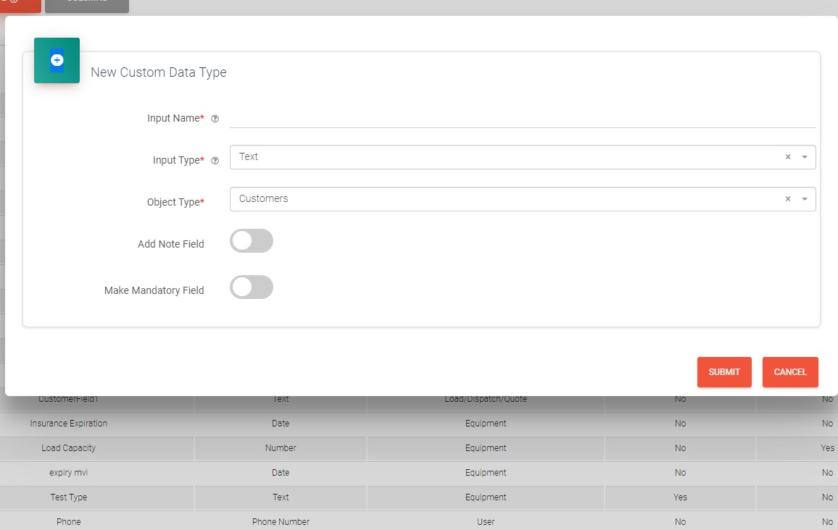
Figure 23: New Custom Data Type Entry
Fig 19 (above) shows the info needed to create a New Custom Data Type:
- Name (self-descriptive so that users understand what it means)
- Input Type (to ensure the right type of data is going into your field) – options are Text, Number, Decimal, Dropdown (list with custom values), Email (address), Phone Number, Date, Time or Datetime (Timestamp).
- Object Type (which table does the field belong to?) – options are Customers, Suppliers, Locations, Drivers& Carriers, Equipment, Quotes/Loads, Users)
- Add Note Field: you can add a Notes/Detail field to record more details for any given record
- Make Mandatory field: this forces the user to enter data into the field in order for their record/ change to be submitted to the system properly.

Carrier Requirement Types
These are extra fields used when a Carrier is selected, it allows you to define from your subcontracted Carrier the requirement that they use a particular type of vehicle (Header) and that it includes specific equipment or configuration (Item). In order to add an Item you must first have created an associated Header, as Items need to be Assigned during the entry of their data (see Fig 18 below)
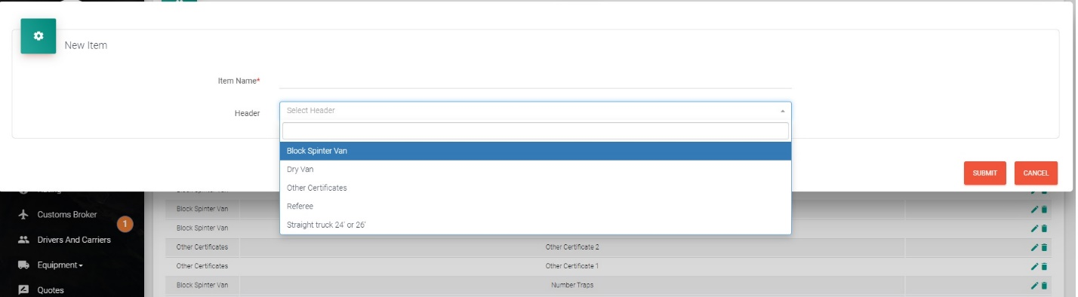
Figure 24: New Carrier Requirement Type

Deduction/Reimbursement Types
These are fields that can be used to detail deductions or reimbursements taken from or made to Drivers/Carriers (per diems, permits, bonuses, phone allowance, etc) and the section of QuickBooks Accounts tables, such Deductions and reimbursements should be recorded against.
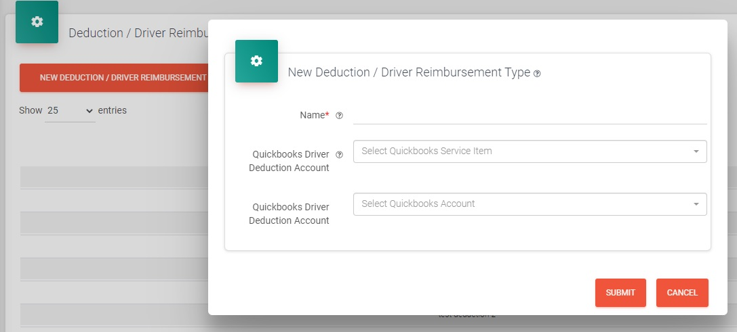
Figure 25: Driver Deduction/Reimbursement Types

Driver/Carrier Ratings
These are survey Questions given to trucking company customers, to allow them to rate and review your Drivers/Carriers once Loads have been delivered
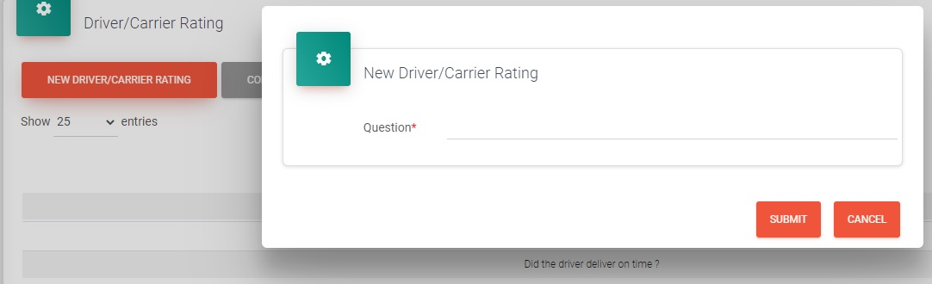
Figure 26: Driver Carrier Rating

Equipment Types
This allows you to create more detailed Equipment types that just a Truck and Trailer (Pickup, Box Van, 5 ton, etc) to provide a more granular description of your organizations vehicles.
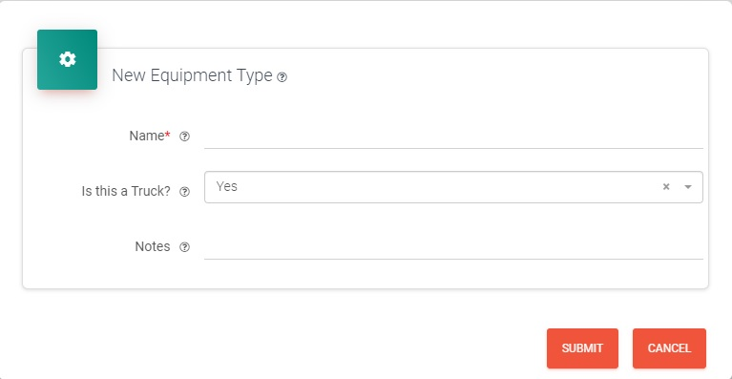
Figure 27: New Equipment Type

Expense/Bill Types
This allows you to create a library of additional cost items to add to Invoices, to cover any additional costs you need to pass on to your customer (waiting time, deadhead miles, etc). As well as giving the expense a Name, you’ll need to let TracXTMS know whether it relates to Drivers/Carriers or Equipment, how it should be charged (Flat Rate or per Mile), the default rate and which QB account it needs to be posted to. You’ll also be able to ask that it be added as a default item to all new Loads.

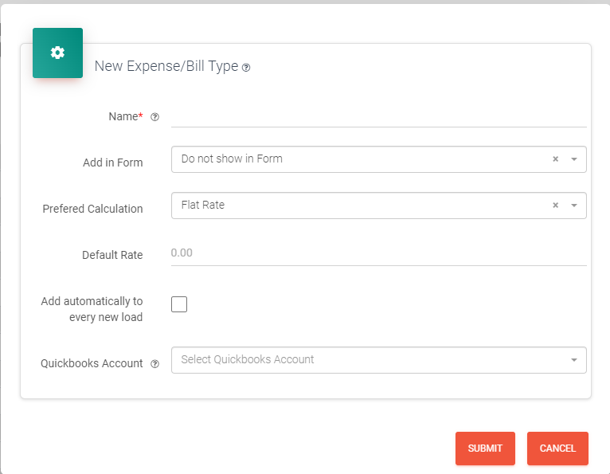
Figure 28: Add New Expense/Billing Type

Fuel Rates
As the price of diesel and gasoline continue to rise more and more companies are relaying this cost as a Fuel Surplus Charge (FSC). You can set up as many rates as you like based on Mileage, a percentage, a Flat Rate, Quantity or based on US DoE figures; they need only names and a Default rate. Other information requested is Driver reimbursement values, a detail note and the Account in QB the expense and the reimbursement would be posted to.
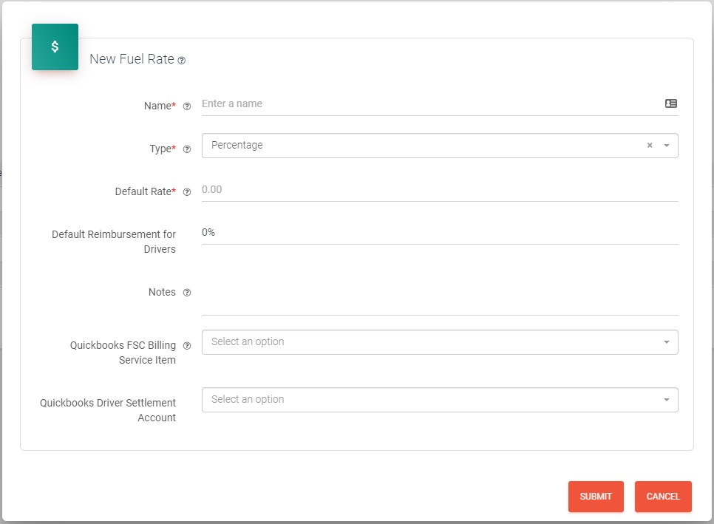
Figure 29: New Fuel Rate

Other Charge/Reimbursement Types
Like Expense/Bill Types, this allows you to add extra charges to a client Bill; however these charges also require the Driver to be reimbursed in relation to the Charge. As well as a name, the system needs to know if it’s a Flat Rate or a Percentage and the default value. It also needs to know which QB account it needs to be posted to, and which account the Driver reimbursement gets posted to.
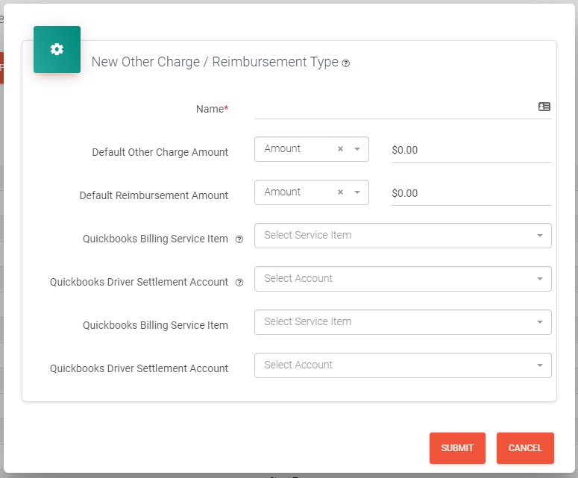
Figure 30: New Other Charge/Reimbursement Type

Purchase Order/Work Order Types
In order to provide external suppliers with Purchase order numbers, and internal maintenance team Work orders, these items can be created and their default QB account listed
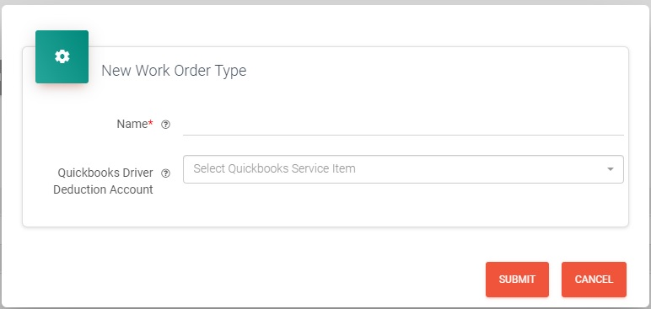
Figure 31: New Purchase/Work Order Type

Rate Type
This allows you to create custom billing rates (by the Gallon, bushel, pallet) so you can bill your customer however you like for the service you provide. You’ll need to provide a name and determine if the rate is Flat or per Mile and which QB accounts are affected by the new Rate.
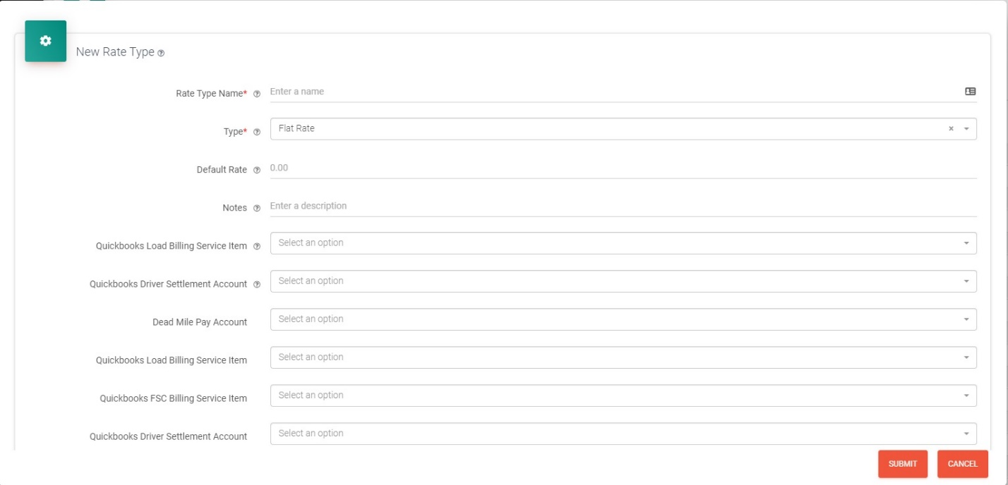
Figure 32: New Rate Types

Reference Numbers
This allows you to record reference numbers, either yours or your customers, in a given number of tables in the system (Billing, other Charges/Reimbursement, Drivers/Carriers, Routing, Map or Notes). It allows you to supress or reveal this information on Documents generated by TracxTMS or on the Drivers version of the system
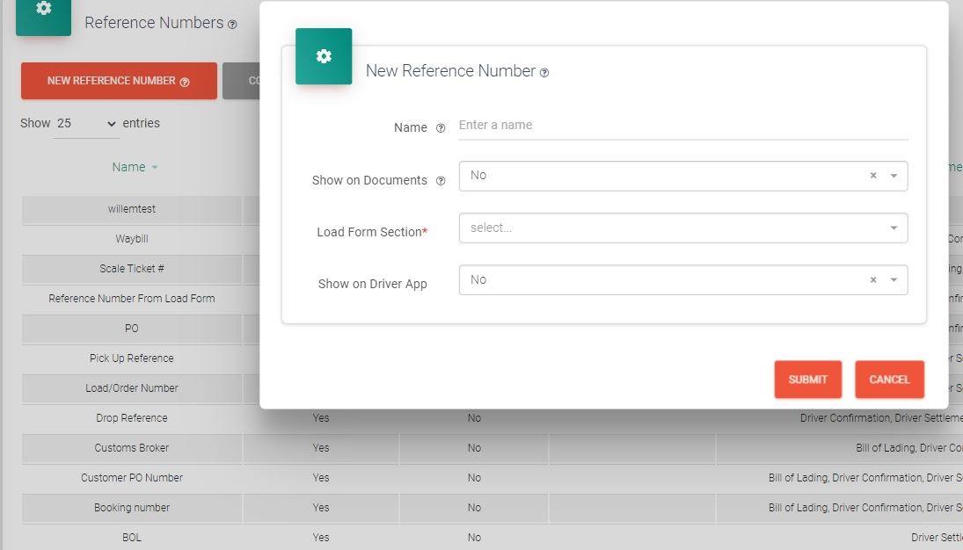
Figure 33: New Reference Number

